PROJECT: AUTOMATIC LIQUID LEVEL
CONTROL SYSTEM

ECE 0323.1 - FEEDBACK AND CONTROL SYSTEM
(LABORATORY)
BS ECE 3-1

SUBMITTED BY:
BS ECE 3-1

Submitted to:
Mr. Charles G. Juarizo
ECE Department
May 6, 2026

ABSTRACT

The Automatic Liquid Level Control System is a feedback-based electronic control project designed to automatically monitor and regulate the water level in a tank. The system uses water probes as sensing elements, an electronic control circuit as the decision-making unit, and a relay-driven pump as the actuating device. Through this arrangement, the circuit detects the water level and automatically switches the pump ON or OFF depending on the condition of the tank, reducing the need for manual operation.
The original design of the system used a 12V transformer, half-wave rectifier, filter capacitor, transistor, silicon-controlled rectifier (SCR), relay, and water probes. In this design, the water probes served as feedback sensors, while the transistor and SCR performed the switching and latching functions necessary for pump control. However, the original circuit had limitations in terms of power supply stability and switching reliability because it used half-wave rectification and did not include voltage regulation.
To improve the system, a redesigned circuit was developed using a bridge rectifier, 220 uF filter capacitor, LM7812 voltage regulator, 555 timer IC, transistor relay driver, flyback diode, and relay output. The bridge rectifier allows full-wave rectification, which makes use of both positive and negative half-cycles of the AC input. The LM7812 voltage regulator provides a stable 12V DC supply, while the 555 timer improves the switching operation of the control circuit. These improvements make the redesigned system more stable, reliable, and suitable for practical liquid level control applications.
The project demonstrates the importance of feedback and control systems in electronics engineering. It shows how sensors, electronic circuits, and actuators can be integrated to form an automatic system capable of responding to real-time physical conditions. The development of the original and redesigned circuits also highlights how proper component selection, power supply design, and PCB layout can significantly affect the performance and reliability of an engineering system.

OBJECTIVES

General Objective
The general objective of this project is to design, analyze, and improve an Automatic Liquid Level Control System using feedback and control system principles, electronic circuit design, and PCB implementation.

Specific Objectives
- To understand the operation of an automatic liquid level control system using water probes, electronic switching components, a relay, and a pump.
- To analyze the original circuit design that uses a half-wave rectifier, transistor, SCR, relay, and water probes for liquid level detection and pump control.
- To identify the limitations of the original circuit, particularly in terms of power supply stability, ripple voltage, switching reliability, and circuit sensitivity.
- To redesign the original circuit by using a bridge rectifier, larger filter capacitor, LM7812 voltage regulator, 555 timer IC, transistor driver, relay, and flyback diode.
- To compare the original and redesigned circuits in terms of rectification method, control mechanism, stability, reliability, and overall circuit performance.
- To apply feedback control principles by using the water level as the controlled variable and the water probes as feedback sensors.

THEORETICAL DISCUSSION

Feedback Control in Liquid Level Systems
The integration of feedback and electronic circuits is fundamental in the design of modern control systems because it enables automatic regulation and improved system performance. Feedback refers to the process of measuring a system output and using that information to adjust the input in order to minimize error and maintain a desired condition. In this project, the water level is the controlled variable, the water probes act as feedback sensors, the electronic circuit serves as the controller, and the relay-driven pump acts as the actuator.
The system operates as a closed-loop control system. When the water level is below the desired level, the probes send a feedback condition to the controller, causing the pump to turn ON. When the water reaches the high-level probe, the feedback condition changes and the controller switches the pump OFF. This process allows the system to regulate the water level automatically without constant manual intervention.

Closed-Loop Control Representation
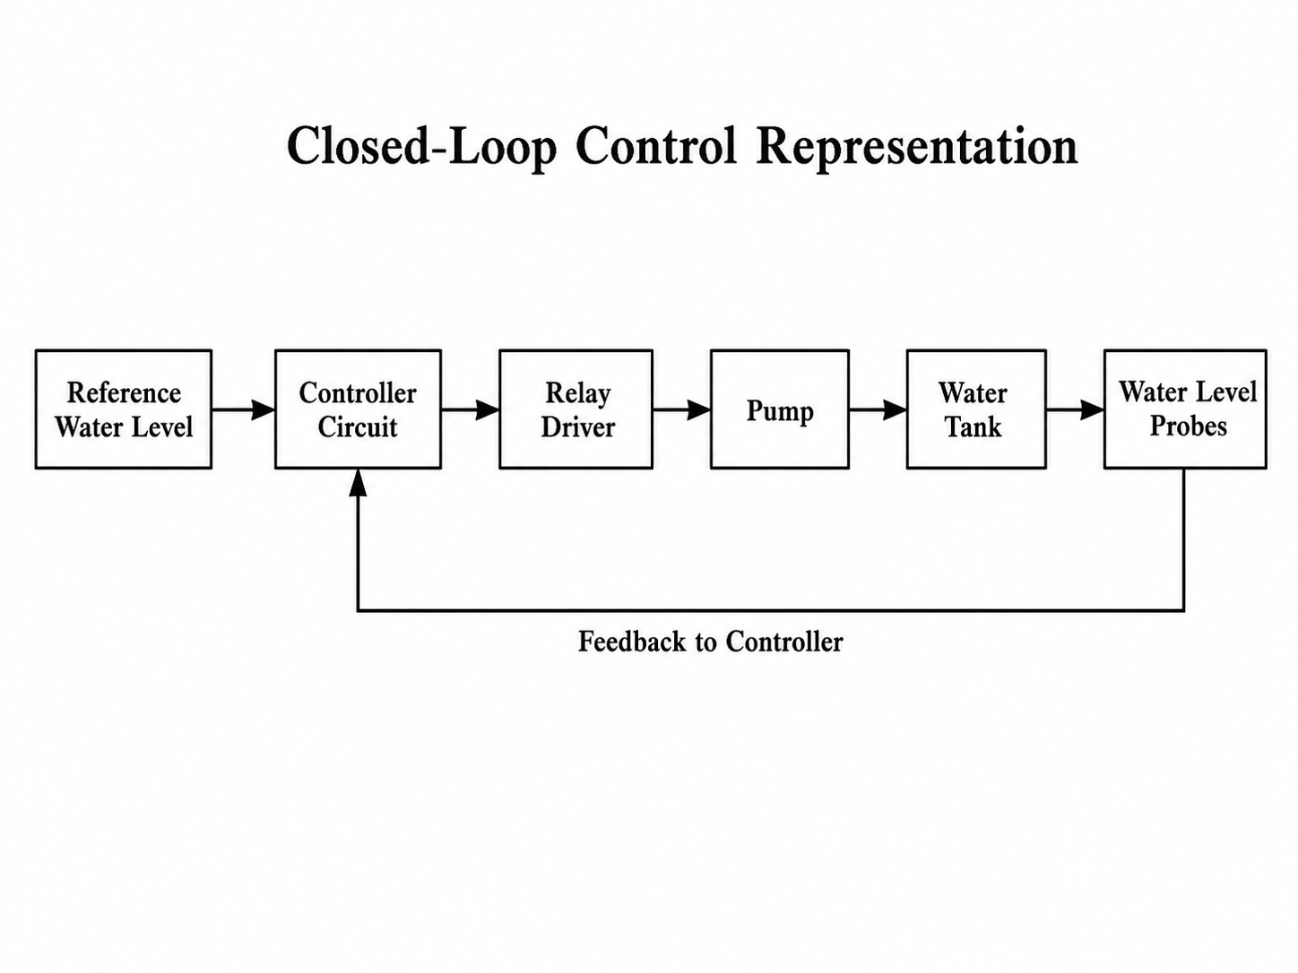
The feedback operation of the system may be represented using the following block diagram sequence:

Role of Electronic Components
Electronic circuits provide the physical implementation of the feedback concept by processing electrical signals and executing control actions. Sensors convert physical conditions into electrical signals, while components such as resistors, capacitors, diodes, transistors, SCRs, voltage regulators, integrated circuits, and relays perform signal conditioning, switching, regulation, and actuation. Together, these components allow the system to continuously monitor and respond to changes in water level.
The power supply section is important because the controller and relay require a stable DC voltage for reliable operation. The sensing section determines the water level condition through the conductivity between probes. The control section decides whether the output should be ON or OFF, and the output section energizes or de-energizes the relay to operate the pump.

A. Original Schematic Diagram
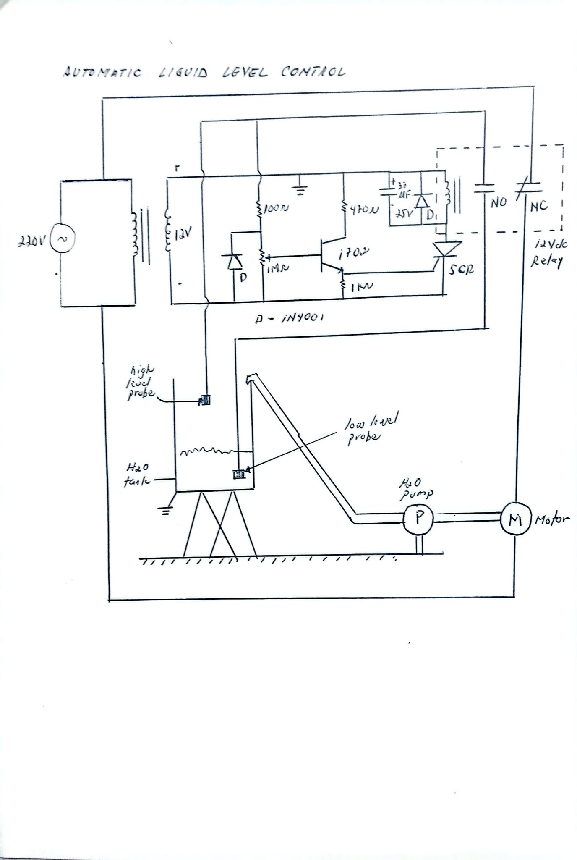
Figure 1. Original hand-drawn schematic diagram of the Automatic Liquid Level Control System.
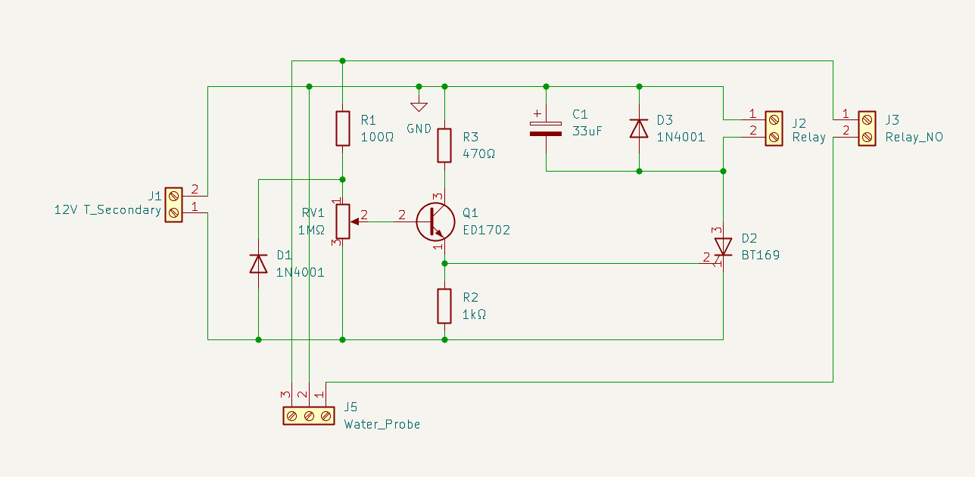
Figure 2. Recreated original schematic diagram showing the transistor-SCR relay control circuit.
The original schematic represents an Automatic Liquid Level Control System designed using a low-voltage control circuit powered by a 12V transformer secondary. The system integrates sensing through water probes, control through a transistor and SCR, and actuation through a relay into a single closed-loop design.
The input stage begins at the 12V AC secondary, where D1, a 1N4001 diode, performs half-wave rectification. This allows only one polarity of the AC signal to pass. Capacitor C1, rated at 33 uF, smooths the rectified signal and provides a more stable DC supply for the transistor, SCR, and relay section. However, because only one half-cycle of the AC waveform is used, the output has more ripple compared to a full-wave rectified supply.
The control stage is centered around Q1, the ED1702 transistor, and D2, the BT169 SCR. The transistor acts as a signal amplifier and switching device, while the SCR functions as a latching device. Once the SCR is triggered, it remains ON until the current drops below its holding current. This latching behavior helps maintain relay operation and prevents unstable switching.
The output stage consists of a relay with a normally open contact. When the SCR is triggered, the relay coil is energized and the normally open contact closes to switch the external load, such as a water pump. Diode D3 is connected across the relay coil as a flyback diode to protect the circuit from voltage spikes produced when the relay coil is switched OFF.

Positive and Negative Half-Cycle Operation of the Original Circuit
During the positive half-cycle, D1 becomes forward-biased and allows current to flow. The capacitor charges and supplies voltage to the control circuit. If the correct signal from the water probes is present, the SCR can be triggered and the relay can turn ON.
During the negative half-cycle, D1 becomes reverse-biased and blocks current from the transformer secondary. However, capacitor C1 discharges through the load and helps maintain the supply voltage until the next positive half-cycle. This reduces voltage fluctuation, although the ripple remains higher compared to a full-wave rectifier.

Reference | Quantity | Component | Value/Specification | Purpose/Function
C1 | 1 | Capacitor | 33 uF | Filters and smooths the rectified voltage to provide a DC supply.
D1, D3 | 2 | Diode | 1N4001 | D1 rectifies AC to DC; D3 protects the relay circuit from back EMF.
D2 | 1 | SCR | BT169 | Acts as a latching switch to maintain the ON state once triggered.
J1 | 1 | Transformer | 12V AC | Steps down the AC voltage to a safer operating level.
J2 | 1 | Relay | 12V DC relay | Switches the pump ON/OFF and isolates the control circuit from the load.
J3 | 1 | Relay contact | Normally open | Connects or disconnects the external pump motor.
J5 | 1 | Water probe | Level sensor | Detects water level and provides feedback signal.
Q1 | 1 | Transistor | ED1702 | Acts as a switch/amplifier to control SCR triggering.
R1 | 1 | Resistor | 100 ohms | Limits current and assists in circuit biasing.
R2 | 1 | Resistor | 1 kohm | Provides biasing and stabilizes transistor operation.
R3 | 1 | Resistor | 470 ohms | Controls transistor base current.
RV1 | 1 | Variable resistor | 1 Mohm | Adjusts sensitivity/calibration of the water detection circuit.

B. Redesigned Schematic Diagram
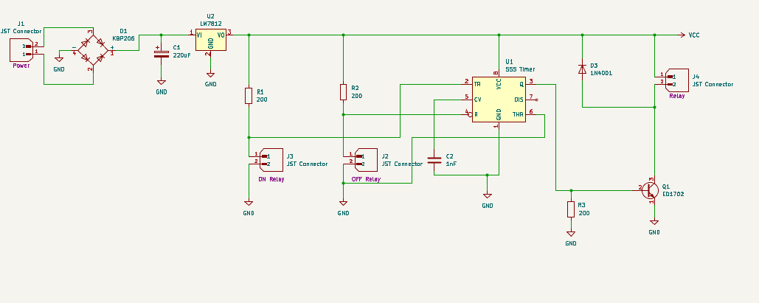
Figure 3. Redesigned schematic diagram using bridge rectifier, LM7812 voltage regulator, 555 timer IC, transistor driver, and relay output.
The redesigned circuit improves the system by using a regulated DC power supply and a 555 timer-based control circuit, making it more stable and reliable compared to the original design. The system starts with a power input where AC voltage is applied and passed through a KBP206 bridge rectifier. This converts the AC input into full-wave pulsating DC. Capacitor C1, rated at 220 uF, smooths the voltage and reduces ripple.
To further enhance stability, the circuit uses an LM7812 voltage regulator, which ensures a constant 12V DC output regardless of moderate input fluctuations. This regulated supply powers the 555 timer and relay driver section. The 555 timer serves as the main control unit, producing a more predictable switching response compared to the original transistor-SCR logic.
The control stage uses the 555 timer configured to respond to input signals from the water probe connectors. The timer determines when the output should switch ON or OFF based on the detected water level condition. Capacitor C2 helps stabilize the timer operation and reduces false triggering due to electrical noise.
The output stage consists of transistor Q1, which acts as a relay driver. When the 555 timer output becomes HIGH, the transistor turns ON and energizes the relay coil. Diode D3 is connected across the relay coil as a flyback diode, protecting the transistor from voltage spikes caused by the relay coil.

Positive and Negative Half-Cycle Operation of the Redesigned Circuit
During the positive half-cycle of the AC input, the bridge rectifier conducts through one pair of internal diodes and produces a positive output polarity. The filter capacitor charges and stores energy for the control circuit.
During the negative half-cycle of the AC input, the bridge rectifier conducts through the opposite pair of internal diodes. Even though the input polarity reverses, the output polarity remains positive. This full-wave rectification uses both half-cycles of the AC input, resulting in a smoother and more efficient DC output compared to half-wave rectification.

Reference | Quantity | Component | Value/Specification | Purpose/Function
C1 | 1 | Capacitor | 220 uF | Filters and smooths rectified DC voltage, reducing ripple.
C2 | 1 | Capacitor | 1 nF | Stabilizes 555 timer operation and reduces noise.
D1 | 1 | Bridge rectifier | KBP206 | Converts AC input into full-wave DC.
D3 | 1 | Diode | 1N4001 | Acts as a flyback diode to protect the transistor from relay spikes.
J1 | 1 | JST connector | Power input | Supplies AC input to the circuit.
J2 | 1 | JST connector | OFF relay input | Input control, such as low-level probe signal.
J3 | 1 | JST connector | ON relay input | Input control, such as high-level probe signal.
J4 | 1 | JST connector | Relay output | Connects to relay/load or pump motor.
Q1 | 1 | Transistor | ED1702 | Acts as a switch to drive the relay.
R1 | 1 | Resistor | 200 ohms | Limits current and assists in biasing.
R2 | 1 | Resistor | 200 ohms | Provides biasing for the 555 timer input.
R3 | 1 | Resistor | 200 ohms | Limits base current of the transistor.
U1 | 1 | Timer IC | 555 timer | Main control unit for switching logic.
U2 | 1 | Voltage regulator | LM7812 | Provides stable 12V DC output.

II. METHODOLOGY
The methodology of the project involved the analysis, redesign, PCB implementation, and testing of an Automatic Liquid Level Control System. The project began with the evaluation of the original circuit, which used a half-wave rectifier, transistor, SCR, relay, and water probes. After identifying possible limitations in stability and reliability, the system was redesigned by using a full-wave bridge rectifier, filter capacitor, LM7812 voltage regulator, 555 timer IC, transistor relay driver, flyback diode, and relay output.
The overall process was divided into three main parts: design procedure, PCB design procedure, and testing procedure. The design procedure focused on the development and improvement of the electronic circuit. The PCB design procedure involved converting the schematic diagram into a practical printed circuit board layout. The testing procedure verified the operation of the power supply, water probe detection, relay switching, and pump control.

A. Design Procedure
The design process started with the analysis of the original automatic liquid level control circuit. The original circuit used a 12V transformer secondary, a 1N4001 diode for half-wave rectification, a 33 uF capacitor for filtering, a transistor, an SCR, a relay, and water probes. The purpose of the original design was to detect the water level in the tank and automatically control the pump using feedback from the probes.
The first stage analyzed was the power supply section. In the original circuit, the AC input from the transformer was converted into DC using only one diode. Since this configuration uses only one half-cycle of the AC waveform, the resulting DC output contains higher ripple and is less stable. The capacitor smooths the rectified signal, but because the circuit does not include voltage regulation, the DC supply may still vary depending on the input voltage and load condition.
The second stage analyzed was the control section. The original design used a transistor and SCR to perform switching and latching operations. The water probes acted as the feedback sensors by detecting the presence or absence of water at certain levels. When the required water level condition was detected, the transistor and SCR controlled the relay operation. However, because the circuit depended on water conductivity, probe placement, and sensitivity adjustment, the switching response could become unstable if the signal from the probes was weak or noisy.
After analyzing the original circuit, the system was redesigned to improve stability and reliability. The redesigned circuit used a KBP206 bridge rectifier instead of a single diode. This allowed the circuit to perform full-wave rectification, using both the positive and negative half-cycles of the AC input. A larger 220 uF capacitor was added to reduce ripple and produce a smoother DC output.
To further improve the power supply, an LM7812 voltage regulator was included in the redesigned circuit. The function of the regulator was to maintain a constant 12V DC output for the control circuit. This helped ensure that the 555 timer and relay driver received a stable supply voltage during operation.
The original SCR-based control section was replaced with a 555 timer-based control stage. The 555 timer served as the main control unit of the redesigned system. It received input signals from the water probe connectors and produced an output signal depending on the detected water level condition. A small capacitor was connected to the 555 timer to reduce noise and prevent false triggering.
The output section used a transistor relay driver. When the 555 timer output became HIGH, the transistor was activated and allowed current to flow through the relay coil. Once the relay was energized, its contact switched the external load, such as the water pump. A 1N4001 flyback diode was placed across the relay coil to protect the transistor from voltage spikes produced when the relay switched OFF.
Through this design process, the redesigned circuit improved the original system by providing a more stable power supply, a more reliable control stage, and better protection for the switching components.

B. PCB Design Procedure
After the schematic diagram was finalized, the circuit was converted into a printed circuit board layout using PCB design software. The purpose of the PCB design was to create a compact, organized, and reliable physical implementation of the automatic liquid level control system.
The first step in the PCB design procedure was to assign the proper footprints for each component. The components included the bridge rectifier, voltage regulator, resistors, capacitors, 555 timer IC, transistor, diode, relay connector, power input connector, and water probe connectors. Each component footprint was selected based on its actual package size to ensure proper placement and soldering during fabrication.
After assigning the footprints, the components were arranged on the board according to their function. The power supply components, such as the bridge rectifier, filter capacitor, and voltage regulator, were placed near the power input connector. This arrangement reduced unnecessary trace length in the power section and allowed stable voltage distribution across the board.
The 555 timer and its supporting components were placed near the center of the PCB. This made the control section compact and reduced the length of signal traces connected to the timer inputs and output. The transistor driver, flyback diode, and relay output connector were placed close to one another to shorten the switching path and improve relay operation.
The water probe connectors were positioned along the edge of the board for easier external wiring. This placement made it easier to connect the low-level probe, high-level probe, and ground probe during testing and actual operation. The relay output connector was also placed near the edge of the board so that the pump or external load could be connected conveniently.
After component placement, the traces were routed. Wider traces were used for power and relay paths because these parts of the circuit carry higher current compared to signal lines. Narrower traces were used for low-current signal connections, such as the 555 timer input and output paths. The ground connections were arranged carefully to provide a common reference point for all components and reduce noise.
Mounting holes were added to the PCB layout to allow secure installation of the board inside an enclosure. Proper spacing was maintained between components and traces to reduce the risk of short circuits, solder bridges, and electrical interference.
After completing the PCB layout, the design was checked for errors such as disconnected nets, overlapping traces, incorrect footprints, and possible short circuits. Once the layout was verified, the PCB design was prepared for fabrication. The layout was transferred to the copper board, etched, drilled, and soldered with the required components.

Original PCB Schematic Design
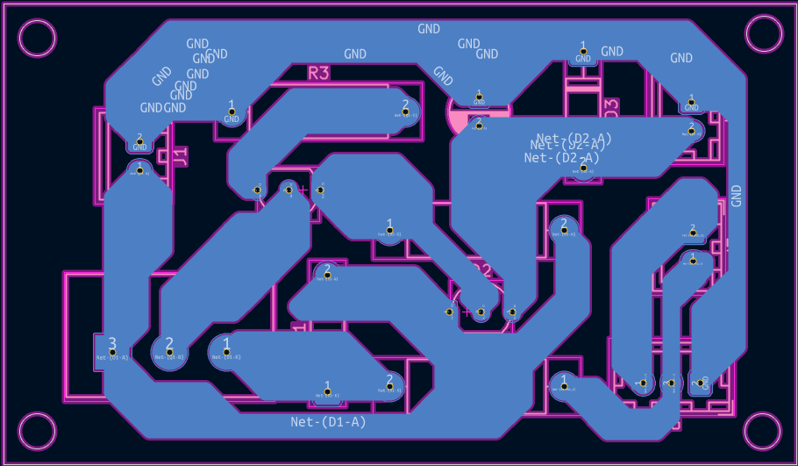
Figure 4. Original PCB layout showing the transistor-SCR based control board.
The original PCB layout shows the physical implementation of the original Automatic Liquid Level Control circuit using a single-layer design with wide copper traces. These thick traces are important for handling current in the power and relay sections because they help reduce resistance and prevent overheating. A large ground plane is also visible across the board, improving stability by minimizing electrical noise and providing a common reference point for the circuit.

New PCB Schematic Design
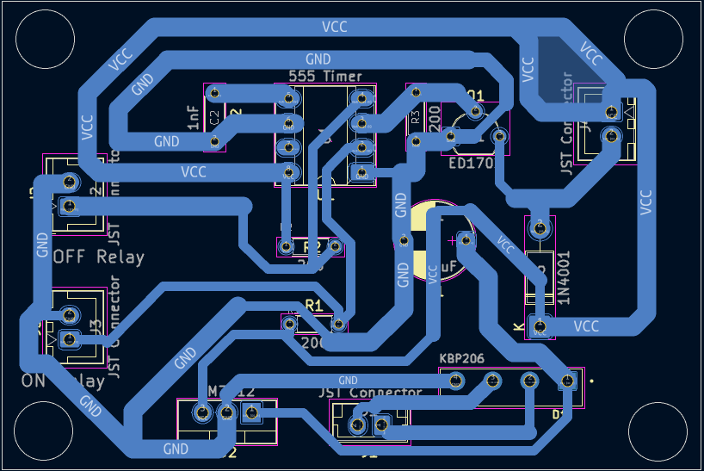
Figure 5. Redesigned PCB layout with improved routing and clearer separation of power, control, and output sections.
The new PCB layout reflects a more refined and organized implementation of the Automatic Liquid Level Control System. Compared to the previous version, this layout shows better trace routing and clearer separation of functional sections, particularly between the power supply, control, and output stages. The transistor and flyback diode are placed near the relay connector, which shortens the high-current switching path and improves protection against voltage spikes.

C. Testing Procedure
The testing procedure was performed to verify whether the redesigned automatic liquid level control system operated correctly. The testing focused on the power supply section, probe detection section, relay switching section, and overall pump control operation.
First, the power supply section was tested. The AC input was applied to the power connector of the circuit. The output of the bridge rectifier and filter capacitor was checked using a multimeter to determine whether the circuit was producing DC voltage. The output of the LM7812 voltage regulator was then measured to confirm that it provided approximately 12V DC to the control circuit.
Second, the water probe detection section was tested. The low-level, high-level, and ground probes were connected to the circuit. The probes were then placed in water at different levels to simulate actual tank conditions. The response of the 555 timer input was observed by checking whether the circuit detected the presence or absence of water at the probe terminals.
Third, the relay switching section was tested. The relay was observed while the water probes were placed in different water level conditions. When the circuit detected a condition requiring the pump to turn ON, the relay was expected to energize. When the water level reached the required upper limit, the relay was expected to de-energize. The clicking sound of the relay and the voltage across the relay coil were used as indicators of proper switching.
Lastly, the complete system was tested with the pump or load connected to the relay output. The water level was allowed to change, and the operation of the pump was observed. The pump was expected to turn ON when the water level was below the required level and turn OFF once the water reached the high-level probe. The results of the test were used to evaluate the effectiveness of the redesigned circuit.
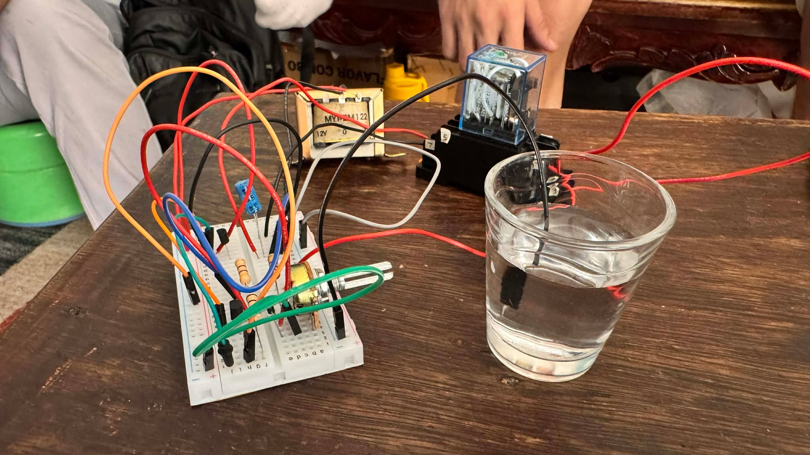
Figure 6. Experimental setup showing the water probe testing arrangement.
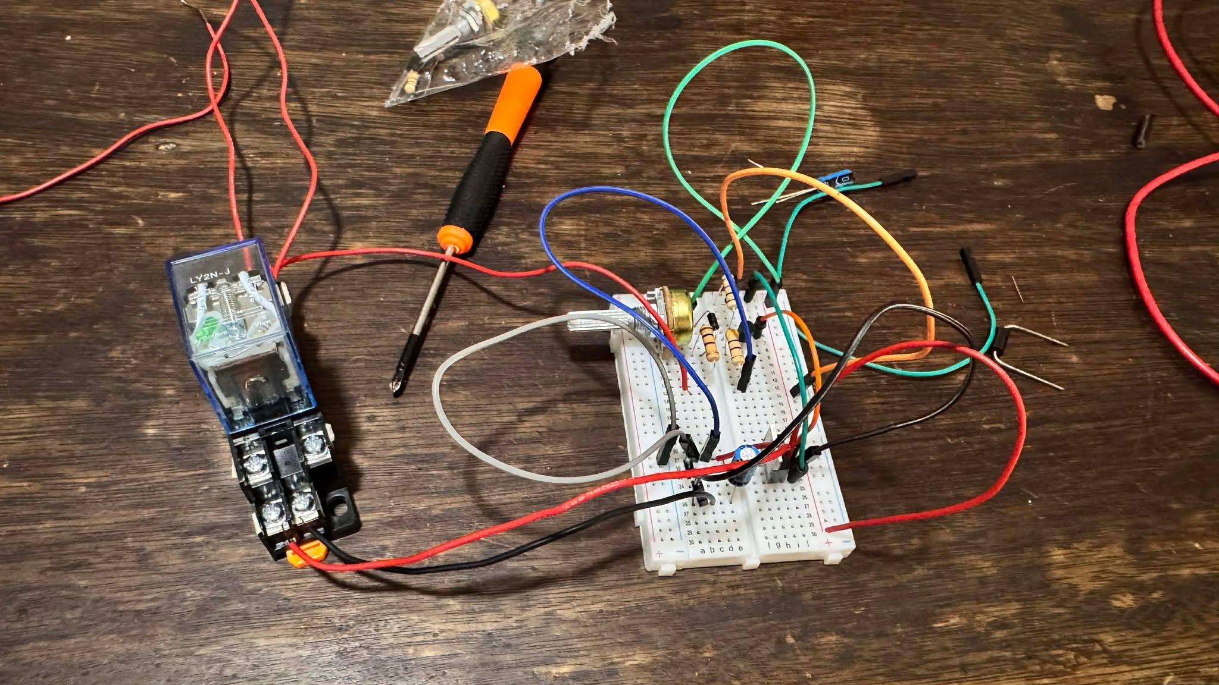
Figure 7. Circuit testing setup with relay module and breadboard connections.

III. RESULTS AND DISCUSSION
The results of the project show that the redesigned automatic liquid level control system improved the operation of the original circuit. The main improvements were observed in the power supply section, control section, and output switching section. The use of a bridge rectifier, larger filter capacitor, voltage regulator, 555 timer IC, transistor driver, and flyback diode contributed to a more stable and reliable system.
The original circuit was able to perform the basic function of automatic liquid level control. However, because it used half-wave rectification and did not include voltage regulation, its DC supply was more affected by ripple and input fluctuations. The redesigned circuit addressed this issue by using full-wave rectification and a regulated 12V DC supply. This allowed the control circuit to operate more consistently.

A. Power Supply Test
The power supply test verified the ability of the redesigned circuit to convert the input AC voltage into a stable DC voltage for the control circuit. In the redesigned circuit, the AC input first passed through the KBP206 bridge rectifier. The bridge rectifier converted both the positive and negative half-cycles of the AC waveform into pulsating DC. This was an improvement over the original circuit, which used only a single diode for half-wave rectification.
After rectification, the 220 uF capacitor filtered the pulsating DC voltage. The capacitor charged during the peaks of the rectified waveform and discharged when the voltage dropped, helping reduce ripple. Compared to the original 33 uF capacitor, the larger capacitor in the redesigned circuit provided better smoothing. The LM7812 voltage regulator then maintained the supply voltage at approximately 12V DC.

Test Point | Expected Result
AC input from transformer | Approximately 12V AC
Output after bridge rectifier and capacitor | Unregulated DC voltage
Output of LM7812 regulator | Approximately 12V DC
VCC supply to 555 timer | Stable 12V DC
Relay supply voltage | Approximately 12V DC

Based on the expected operation, the redesigned power supply provides better performance than the original design because it uses full-wave rectification, larger filtering capacitance, and voltage regulation. This results in a more stable DC supply for the control circuit.

B. Probe Detection Test
The probe detection test was conducted to verify whether the circuit could detect the water level through the low-level, high-level, and ground probes. The probes act as the feedback sensors of the system. When the water touches the probes, a conductive path is formed, allowing the circuit to recognize the water level condition.
In the system, the water level serves as the controlled variable. The probes provide feedback to the control circuit by indicating whether the water is below the minimum level or has already reached the maximum level. The 555 timer processes this input condition and determines whether the pump should turn ON or OFF.
Water Level Condition | Expected Circuit Response
Water below low-level probe | Pump/relay turns ON
Water touches low-level probe | Circuit detects water presence
Water between low-level and high-level probes | Pump continues depending on control state
Water touches high-level probe | Pump/relay turns OFF
Ground probe connected to water | Common reference is established

The probe detection test shows the feedback operation of the system. The water probes allow the circuit to respond automatically to changes in water level. This demonstrates the closed-loop nature of the system, where the output condition is continuously monitored and used to control the pump operation.

C. Relay/Pump Switching Test
The relay and pump switching test was conducted to determine whether the output stage of the circuit could properly control the external load. In the redesigned circuit, the 555 timer output controls the base of the transistor. When the timer output is HIGH, the transistor turns ON and allows current to flow through the relay coil. This energizes the relay and switches the pump or load circuit.
When the relay is energized, its normally open contact closes and allows power to be supplied to the pump. When the relay is de-energized, the contact opens and disconnects the pump from the supply. This switching action allows the circuit to automatically control the pump based on the water level detected by the probes.

Test Condition | Expected Relay Response | Expected Pump Response
Low water level detected | Relay energized | Pump ON
High water level detected | Relay de-energized | Pump OFF
555 timer output HIGH | Relay energized | Pump ON
555 timer output LOW | Relay de-energized | Pump OFF
Relay switched OFF | Flyback diode protects transistor | No unstable switching

The relay/pump switching test verifies the actuation part of the feedback control system. The relay serves as the interface between the low-power control circuit and the higher-power pump/load circuit. Based on the expected operation, the redesigned circuit provides reliable switching and proper isolation between the control and output stages.

D. Original vs. Redesigned Comparison
The original and redesigned circuits both aim to perform the same function: automatic control of liquid level using feedback from water probes. However, the redesigned circuit provides several improvements in terms of power supply stability, control reliability, switching performance, and practical implementation.
The original circuit used a single diode for half-wave rectification. This means only one half-cycle of the AC input was used, resulting in a less efficient and less stable DC supply. In comparison, the redesigned circuit used a bridge rectifier, which allowed full-wave rectification. This made use of both positive and negative half-cycles, producing a smoother DC output.
In terms of control operation, the original circuit used a transistor and SCR combination. The SCR provided latching behavior, but the circuit could be sensitive to water conductivity, probe placement, and signal noise. The redesigned circuit used a 555 timer IC as the main control unit, which provided more predictable and stable switching operation.
Feature | Original Design | Redesigned Design | Improvement
Rectification method | Half-wave rectification using 1N4001 diode | Full-wave rectification using KBP206 bridge rectifier | More efficient AC-to-DC conversion
Filter capacitor | 33 uF | 220 uF | Better smoothing and reduced ripple
Voltage regulation | No voltage regulator | LM7812 voltage regulator | Stable 12V DC output
Main control element | Transistor and SCR | 555 timer IC with transistor driver | More stable and predictable switching
Relay protection | Flyback diode used | Flyback diode retained | Protects switching transistor from voltage spikes
Sensitivity adjustment | Uses 1 Mohm variable resistor | Timer-based input circuit | More consistent operation
PCB layout | Functional but less organized | More refined and organized layout | Better component placement and routing
Power stability | More affected by ripple and input variation | More stable due to full-wave rectification and regulation | Improved reliability
Practicality | Works for basic level control | More suitable for stable operation | Better for practical implementation

On paper, the redesigned circuit offers several advantages over the original: a regulated supply voltage, full-wave rectification with greater filter capacitance, a defined hysteresis band through the use of two separate probe inputs to a bistable controller, and a more organized PCB layout. The realization of these advantages in the assembled prototype, however, depends on correct implementation of the control topology and the probe interface. The Observation section that follows examines the assembled prototype in detail and discusses where the design as implemented succeeds and where it requires correction.

IV. OBSERVATION
The redesigned circuit was fully assembled on the fabricated PCB and connected to the test setup, but it did not produce the expected automatic switching behavior during testing. The power supply section operated as intended and delivered approximately 12 V DC at the LM7812 output, confirming that the bridge rectifier, 220 uF filter capacitor, and voltage regulator were functioning correctly. However, the control and output stages did not respond to the water probe inputs in the manner predicted by the closed-loop design. A systematic review of the assembled circuit and the schematic was therefore conducted to identify the cause of the malfunction. This review identified three design issues that, together, prevent the redesigned circuit from operating as a bistable two-position level controller.

A. Power Supply Section — Functional
The power supply produced the expected DC rail. The 12 V AC input from the transformer secondary was rectified by the KBP206 bridge rectifier and filtered by the 220 uF capacitor, producing an unregulated DC voltage near the calculated value of 12·√2 − 2·V_diode ≈ 15.5 V at light load. The LM7812 maintained an output near 12 V DC, sufficient to power the 555 timer and the relay coil. The headroom between the unregulated rail and the LM7812 dropout threshold is narrow at this transformer voltage, and a future revision should either raise the secondary to 15–18 V AC or increase C1 to 1000 uF or larger to reduce ripple. However, this is not the cause of the observed malfunction; the regulator output measured stable across the duration of testing.

B. Identified Issue 1 — Base Resistor Topology of the Relay Driver
In the implemented schematic, R3 (200 ohms) is placed between the base of Q1 (ED1702) and ground, while pin 3 of the 555 timer connects directly to the base of Q1 with no series resistor in the path. This means there is no current-limiting resistor between the 555 output and the transistor base. When the 555 output is HIGH, the base–emitter junction of Q1 clamps at approximately 0.7 V, and the current flowing into the base is limited only by the internal output impedance of the 555 and the saturation behavior of the base junction. This produces excessive base drive and overstresses both the 555 output stage and the transistor. The correct topology is to place a series base resistor of approximately 1 kohm between pin 3 of the 555 and the base of Q1, which limits the base current to about 10 mA — sufficient to saturate the ED1702 driving a 30–40 mA relay coil while remaining safely within the 555 output rating.

C. Identified Issue 2 — Polarity of the THRESHOLD Input
For a 555 timer in bistable mode, pin 2 (TRIGGER) is active LOW and pin 6 (THRESHOLD) is active HIGH. The output is set HIGH when TRIGGER is pulled below 1/3·V_CC, and is reset LOW when THRESHOLD is pulled above 2/3·V_CC. In the implemented schematic, the OFF probe connector (J2) is wired between pin 6 and ground, with R2 (200 ohms) acting as a pull-up to V_CC. This means that when J2 closes, pin 6 is pulled toward ground rather than toward V_CC. Because THRESHOLD only responds to a HIGH transition, this wiring cannot reset the latch under any condition. The output of the 555 therefore has no valid OFF path, which is consistent with the observed inability of the prototype to switch the relay OFF after activation. The correct topology requires that the high-level probe pull pin 6 toward V_CC when water is detected. This can be achieved by either reversing the resistor and probe positions on the THRESHOLD line (probe to V_CC, pull-down to ground), or by reconfiguring the probe network as described in the next subsection.

D. Identified Issue 3 — Probe Topology
The implemented schematic provides only two probe connectors (J2 and J3), each wired as a switch to ground. A bistable level controller using water conductivity as the sensing mechanism requires three electrodes in the tank: a common electrode tied to V_CC at the bottom of the tank, a low-level probe positioned at the desired minimum water level, and a high-level probe positioned at the desired maximum water level. When the water rises above each probe, conduction through the water completes a path from V_CC to that probe, pulling the corresponding 555 input toward V_CC. With only two connectors and no V_CC reference electrode, the present probe network cannot produce the voltage transitions required to set and reset the 555 latch. The correct probe arrangement uses pull-down resistors of 10–100 kohm on pin 2 and pin 6, with the low-level probe wired to pin 2, the high-level probe wired to pin 6, and a third common probe tied to V_CC. The pull-up values of 200 ohms used on R1 and R2 are also too low for direct probe sensing, since they would cause excessive current through the water path and accelerate electrolytic corrosion of the probes.

E. Combined Effect of the Identified Issues
Each of the three identified issues affects a different stage of the control path. Issue 1 affects the relay driver and prevents reliable transistor operation regardless of the controller output. Issue 2 affects the bistable controller itself and prevents the OFF transition. Issue 3 affects the sensing layer and prevents the controller from receiving valid inputs at all. The combined effect is that the redesigned circuit, while correctly assembled per the existing schematic, cannot perform the closed-loop level control function as designed. This is consistent with the observed behavior of the prototype during testing. The original circuit, which used the simpler SCR latch and single-probe topology, did not exhibit these specific failure modes because its control structure did not depend on the same set of input transitions, although that design carried its own set of limitations as discussed earlier in this report.

F. Proposed Corrected Design
Based on the analysis above, the corrected design retains the power supply section, the LM7812 regulator, the 555 timer, the transistor relay driver, the flyback diode, and the relay output. The following changes are required: (1) move R3 from the base–ground position to a series position between pin 3 of the 555 and the base of Q1, with a value of 1 kohm; (2) reconfigure the probe network to use three electrodes — a common electrode tied to V_CC, a low-level probe to pin 2, and a high-level probe to pin 6 — with pull-down resistors of approximately 47 kohm on pin 2 and pin 6; (3) increase R1 and R2 to the 47 kohm range to limit current through the probe water path and reduce electrolytic wear; (4) raise the transformer secondary to 15–18 V AC or increase C1 to 1000 uF to widen the LM7812 headroom; and optionally (5) increase C2 from 1 nF to 10 nF on the control voltage pin to improve noise immunity. Implementing these changes is expected to produce the bistable two-position behavior described in the theoretical discussion, with hysteresis defined by the vertical separation of the low- and high-level probes inside the tank.

V. CONCLUSION

A. Project Summary
The Automatic Liquid Level Control System was developed as a closed-loop, two-position controller intended to maintain the water level in a tank between a low and a high set point without manual intervention. The project was carried out in two iterations: an original design built around a half-wave rectifier, transistor, and SCR latch, and a redesigned version built around a full-wave bridge rectifier, a 220 uF filter capacitor, an LM7812 voltage regulator, a 555 timer intended for bistable operation, a transistor relay driver, and a flyback diode. The redesigned circuit was fabricated as a PCB, fully assembled, and tested.
Testing showed that the power supply section of the redesigned circuit performed as expected, producing a stable 12 V DC rail at the output of the LM7812. However, the control and output stages did not produce the expected bistable switching behavior. A systematic review of the schematic identified three design issues responsible for the malfunction: an incorrect base-resistor topology in the relay driver, a reversed polarity on the THRESHOLD input of the 555 timer, and a probe network with insufficient electrodes for water-conductivity sensing. Each issue was traced to its underlying principle of operation, and a corrected design was proposed that retains all components of the present implementation while reorganizing the connections of R3, R1, R2, and the probe network. The project therefore did not deliver a fully working redesigned prototype, but it produced a documented diagnostic analysis of the assembled circuit and a defined path to a working implementation.

B. Relevance and Contribution to Engineering
This project illustrates the engineering value of systematic diagnostic analysis when a designed system does not behave as expected. The non-functioning prototype was traced through its three control stages — sensing, decision-making, and actuation — and each stage was checked against the operating principles of its corresponding component. This process identified specific, named design errors rather than vague claims of unreliability, which is the standard method by which working engineers debug control hardware in industry. The exercise reinforced that closed-loop control depends on each stage producing the correct signal in the correct direction, and that a topology error in any stage can prevent the loop from closing even when individual components are intact and correctly chosen.
The two-position control law used in this project, with hysteresis defined by separate ON and OFF set points, is the same control law that operates in many real systems including domestic water pumps, sump pumps, refrigeration thermostats, and basic industrial level controls. The corrected design proposed in the Observation section is consistent with standard practice for this class of controller, and implementing it would produce a working unit that demonstrates the closed-loop behavior described in the Theoretical Discussion. The lessons drawn from comparing the original SCR-based design, the redesigned 555-based design, and the corrected design proposed here will continue to apply when similar control problems are addressed using microcontrollers, programmable logic controllers, or more sophisticated analog control loops in subsequent coursework and professional practice.

VI. APPENDICES

Appendix A. Experimental Setup and Circuit Testing


Figure A1. Breadboard testing of the automatic liquid level control circuit using water probes.


Figure A2. Relay module and breadboard connection used during functional testing.

Appendix B. KiCad Schematic Design and PCB Layout

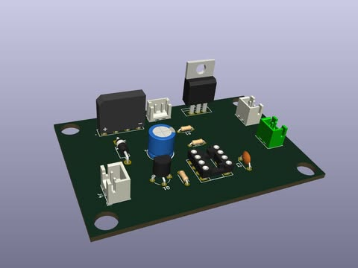
Figure B1.. KiCad 3D model of the original PCB layout showing connectors, resistors, capacitor, transistor, relay input, and probe terminals.

Appendix C. PCB Layout Transfer and Etching Process
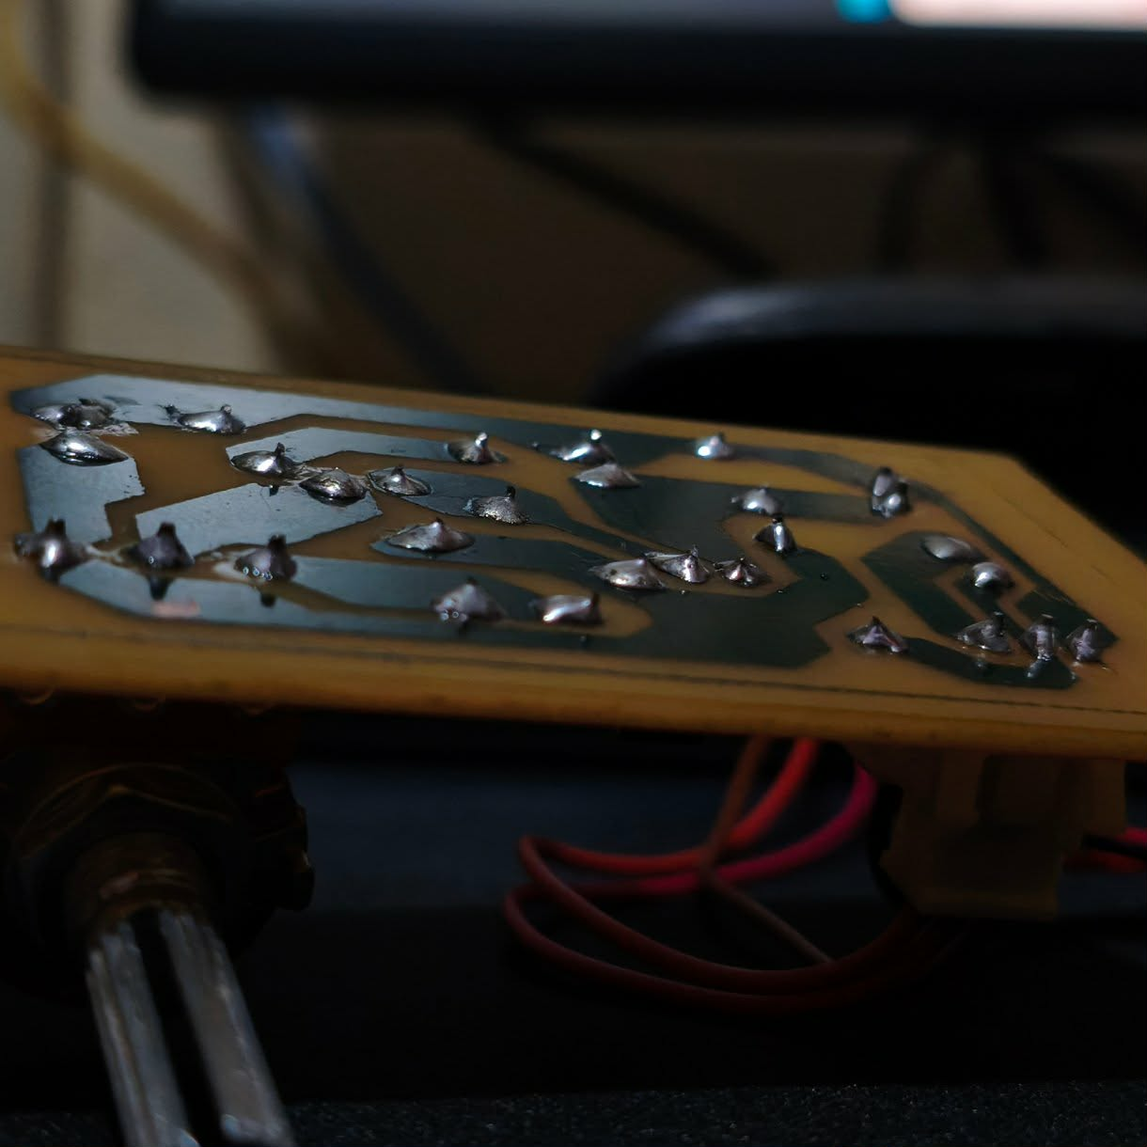
Figure C1. Fabricated PCB after etching and soldering viewed from the copper side.
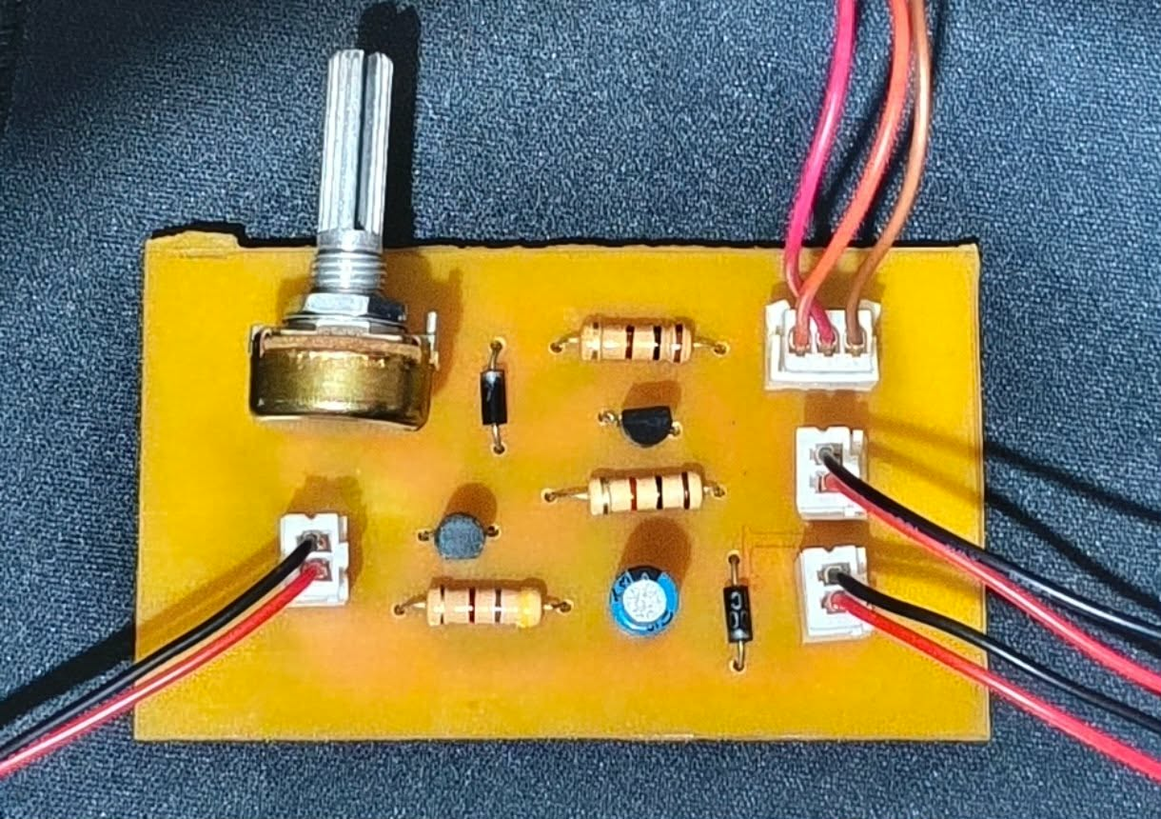
Figure C2. Fabricated PCB after component placement and soldering.

Appendix D. Project Illustration

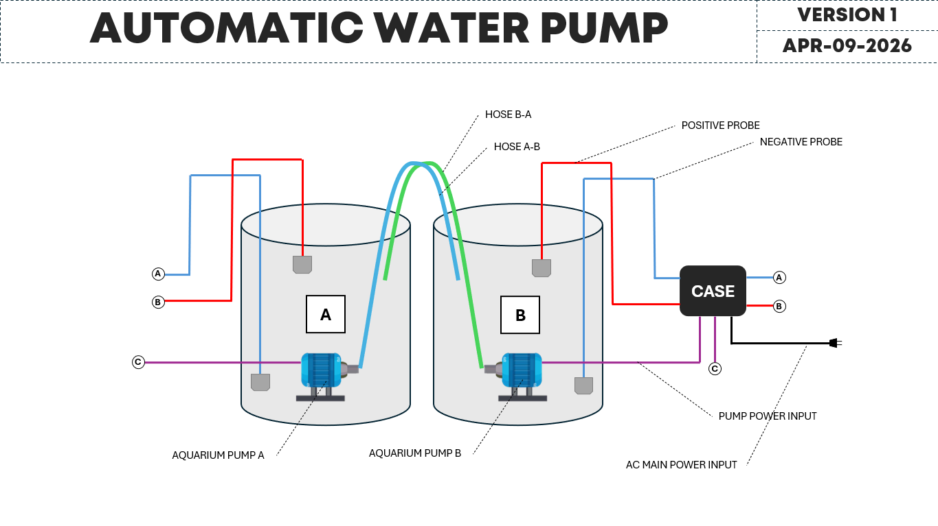

Figure D1. Automatic water pump system illustration showing tank probes, pumps, and control case.

Appendix E . Project Output
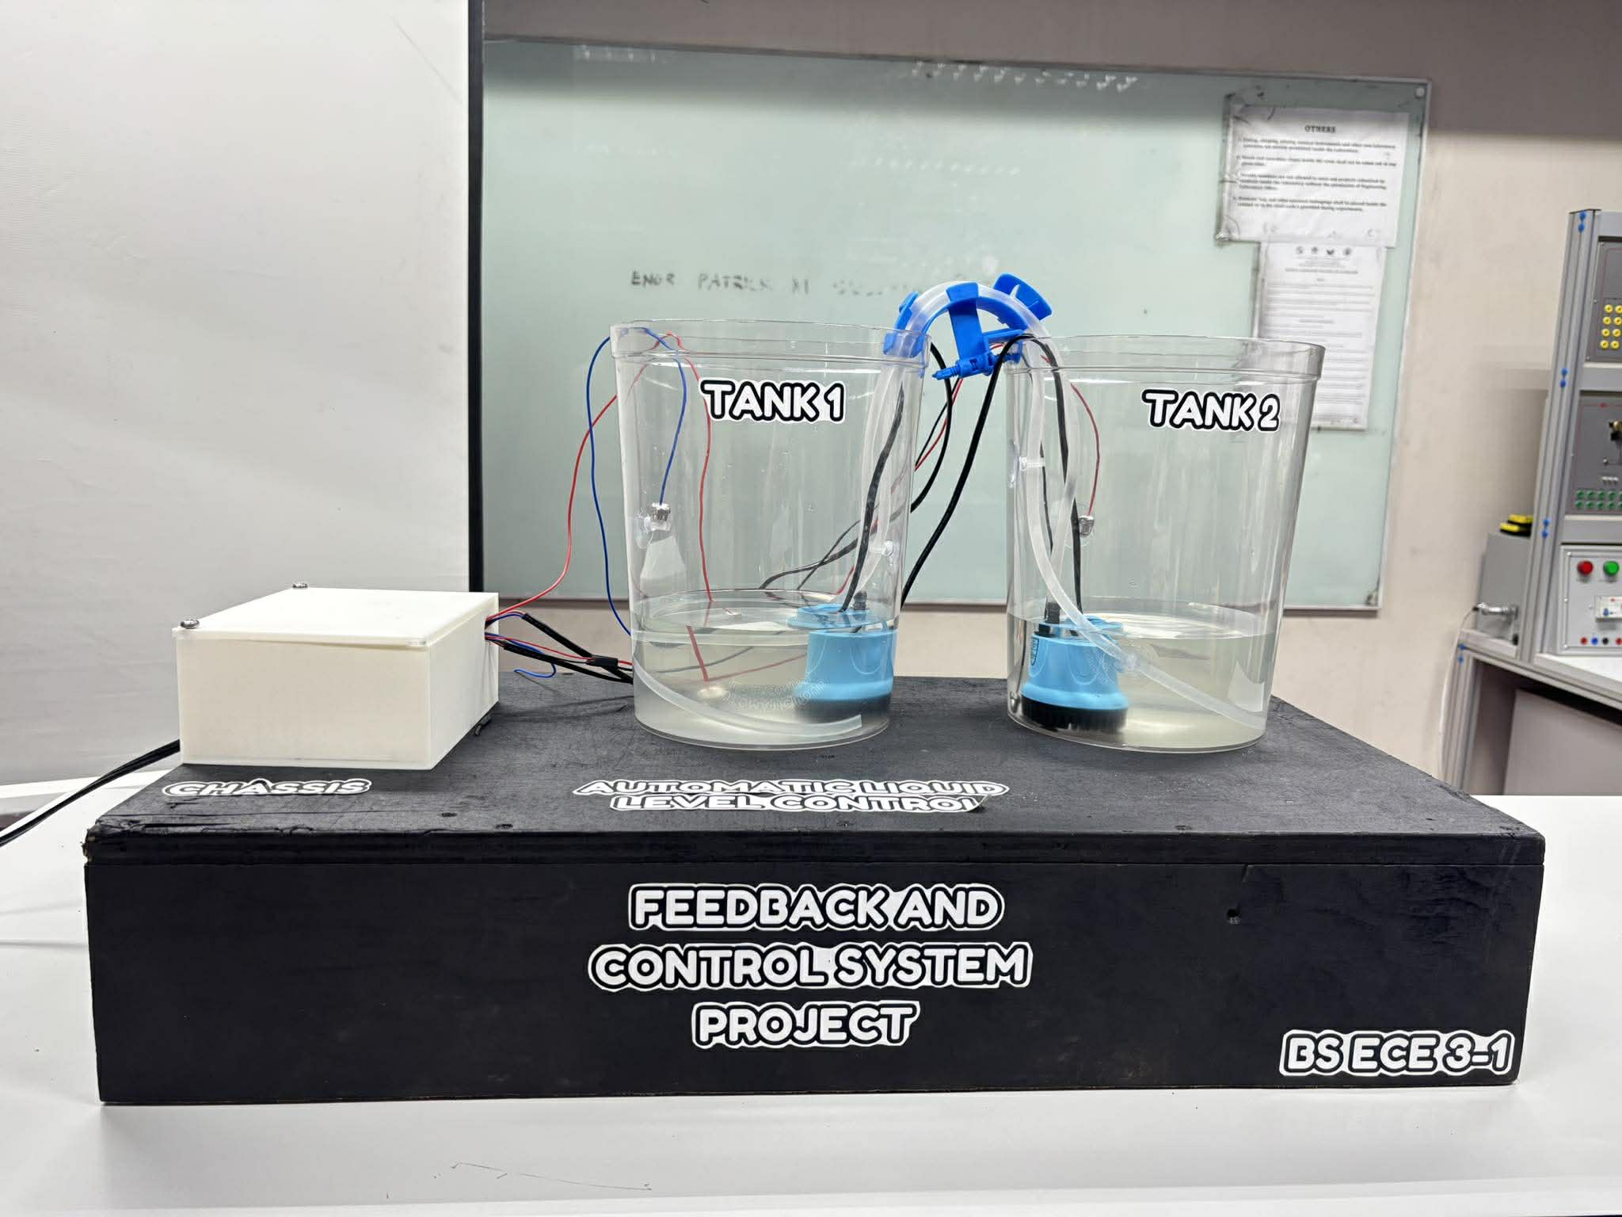
Figure E1. Final Prototype

